**CS414**

**Assignment 4**

**Prepared By**

**Varsha Chandrashekar**

**Harshil K Shah**

**Sandeep Kasavaraju**

**Table of Contents**

**1. Sequence Diagrams**

**1.1 MakePayment**

**1.2 RemoveOrderItem**

**1.3 AddNewItem**

**1.4 DeleteItem**

**2. Design Class Diagram**

**3. System Test Plan**

**3.1 Unit Test**

**3.2 System Test**

**4. Role of Developer**

**5. Commit Logs**

**1. Sequence Diagrams**

**1.1 MakePayment**

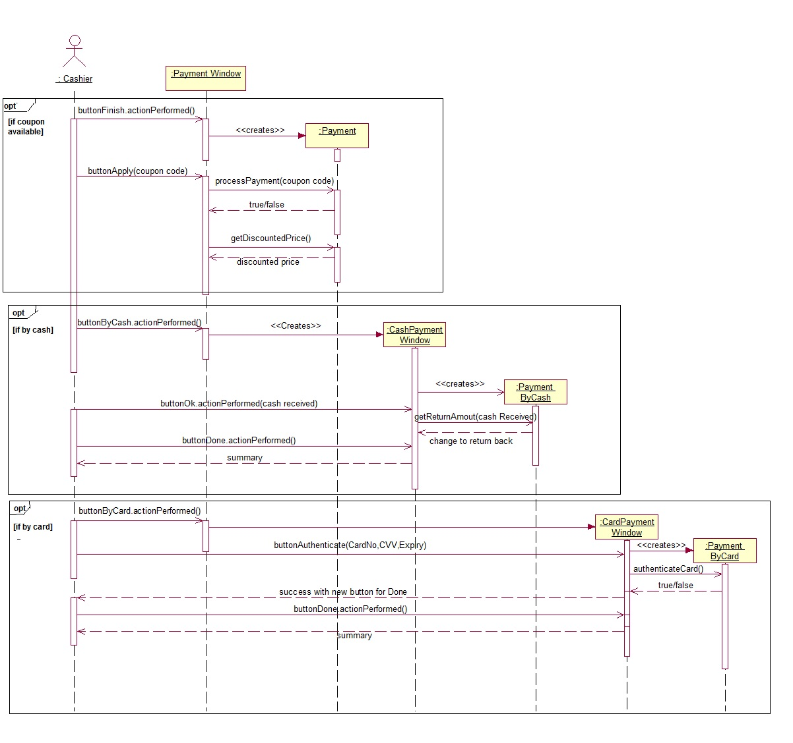

**1.2 RemoveOrderItem**

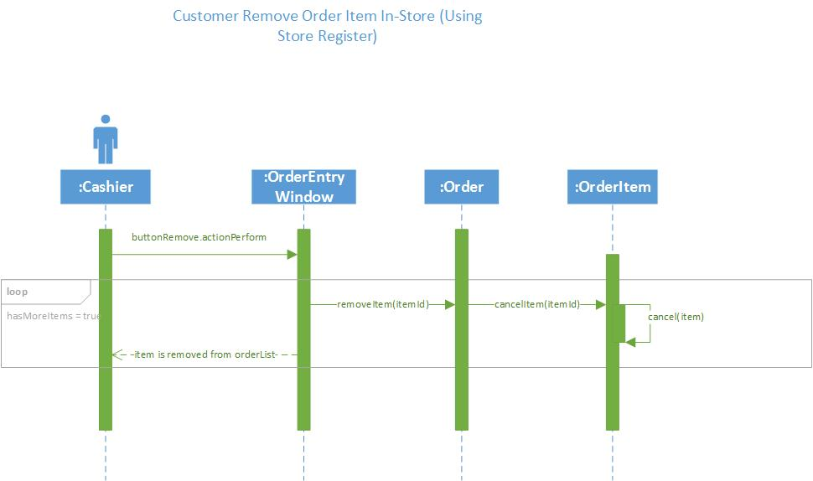

**1.3 AddNewItem**

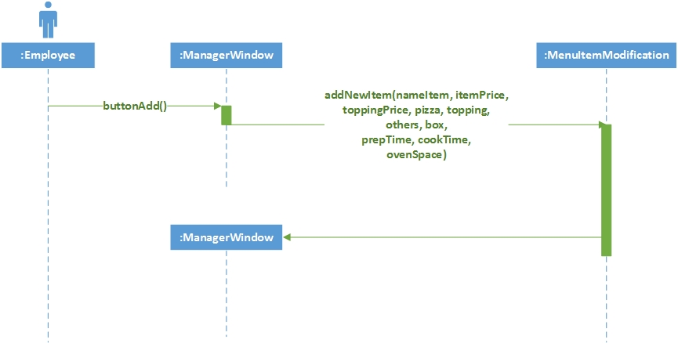

**1.4 DeleteItem**

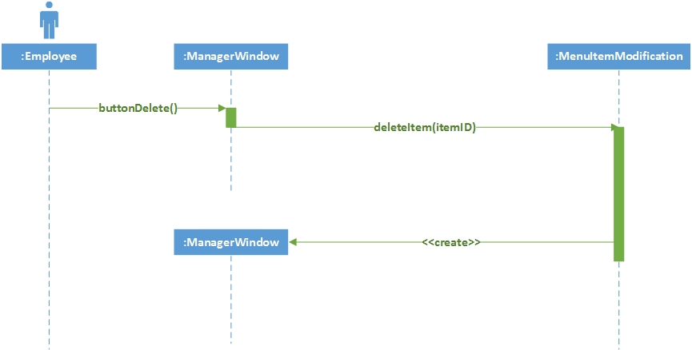

**2 Design Class Diagram**

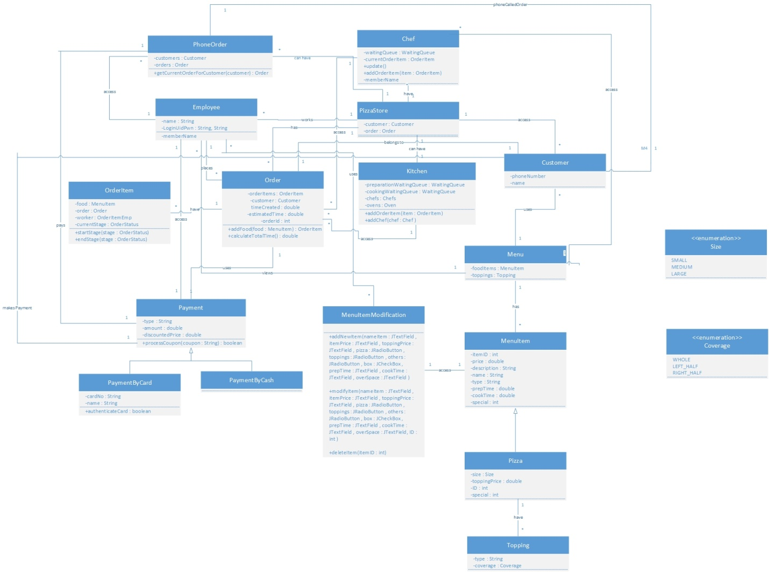

**For better looking find attachment**

**3 System Test Plan**

**3.1 Unit Testing**

| Ref | Function | Test Objective | Evaluation Criteria | X-Ref | P |
| --- | --- | --- | --- | --- | --- |
| OrderTest | | | | | |
| 1 | testAddItem | The objective of the test is to test if the Customer or Cashier is able to add a Menu item to the order. | Expected: Item of type MenuItem is added to Order.  Result: As expected. | OrderItem  MenuItem | High |
| 2 | testRemoveItem | The objective of the test is to test if the item is removed from the order when Customer decides to remove the item | Expected: Item is removed from the order.  Result: As expected | OrderItem  MenuItem | High |
| 3 | testGetPrice | The objective of the test is to test if the total price of the ordered items is computed. | Expected: Sum of all OrderItems is returned.  Result: As expected. | OrderItem | High |
| 4 | testCancelOrder | The objective of the test is to test if the entire order is cancelled when the Customer decides so. | Expected: The order is cancelled.  Result: As expected. | OrderItem | High |

| Ref | Function | Test Objective | Evaluation Criteria | X-Ref | P |
| --- | --- | --- | --- | --- | --- |
| MenuItemTest | | | | | |
| 1 | testParsing | The objective of the test is to test whether menu file is parsed or not | Expected: MenuItem local variables will be initialized  Result: As expected | MenuItem | High |

| Ref | Function | Test Objective | Evaluation Criteria | X-Ref | P |
| --- | --- | --- | --- | --- | --- |
| MenuItemModificationTest | | | | | |
| 1 | testAddNewItem | The objective of the test is to test if new item is added to menu | Expected: New item will be added to menu.txt.  Result: As expected. | Menu  MenuItem | High |
| 2 | testModifyItem | The objective of the test is to test if we can modify item or set special to menuitem | Expected: Changes will be made according to data modified  Result: As expected | Menu  MenuItem | High |
| 3 | testDeleteItem | The objective of the test is to test if we can delete selected item | Expected: Changes will be made according to data deleted. Item's description will be deleted from menu.txt  Result: As expected | Menu  MenuItem | High |
| 4 | testModifyPizza | The objective of the test is to test if we can modify pizza item details or set special to anytype of pizza | Expected: Changes will be made according to data modified  Result: As expected | Menu  MenuItem | High |

| Ref | Function | Test Objective | Evaluation Criteria | X-Ref | P |
| --- | --- | --- | --- | --- | --- |
| MenuTest | | | | | |
| 1 | testFileExist | The objective of the test is to test if file exist in source folder & whether parsing is working | Expected: Toppings & MenuItem variable will be initialized.  Result: As expected. | MenuItem | High |
| 2 | testParsingError | The objective of the test is to test what will happen if file does not match parsing criteria | Expected: Parsing error will be thrown  Result: As expected | MenuItem | High |

**4 Role of Developers**

|  |  |  |
| --- | --- | --- |
| Role | Staff Member | Responsibilities |
| Project Developer | Varsha Chandrashekar | Responsible for overall UI design, implementation of logic for Order (place, modify, cancel), Add toppings, View Order status, Login logic, Order backup, Customer backup, Welcome screen. |
| Project Developer | Harshil Shah | Responsible for Manager User Interface, implementation of logic of Menu Item modification, deletion, addition , & setting special for today. Also responsible for integration of all work done by project developers & for documentation |